**UI DESIGNS FOR MEDIPAL**

**VERSION 1:**

* Home screen:

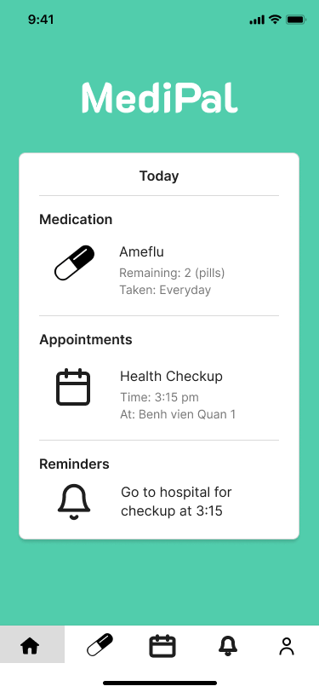

* Medications list:

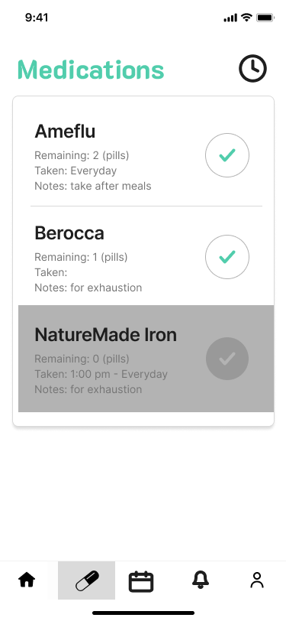

**VERSION 2:**

* Home screen:

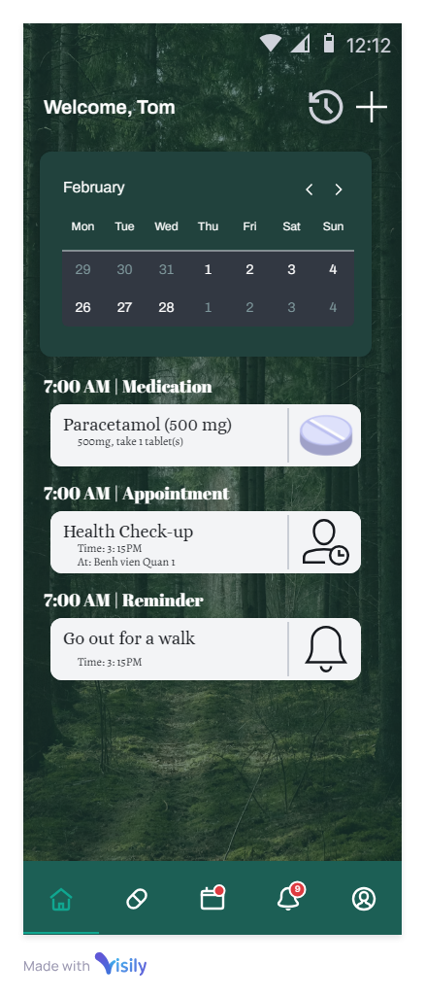

* Medications list:

